**PROJECT FINAL REPORT**

1. **Introduction**

**Project Title** : AIRLINE MANAGEMENT SYSTEM

**College name** : IDEAL INSTITUTE OF TECHNOLOGY

**Team ID :**LTVIP2025TMID29763

**Team Size** : 4

**Team Members:**

|  |  |
| --- | --- |
| **Team Leader** | Kona Veera Venkata Sai Mounika  mounikakona26@gmail.com |
| **Team member** | Jampa Poorna Chandra Mouli  chandramoulijampa1985@gmail.com |
| **Team member** | Ganja Bhanu Sri  bhanusriganja13@gmail.com |
| **Team member** | Harsha Gana Pramod Muvvala  muvvalaharsha77@gmail.com |

**1.INTRODUCTION:**

**1.1 PROJECT OVERVIEW**

**Airlines Management System**

**Hardware Required:**

A laptop or computer with internet connection

**Software Required:**

Salesforce account or org

This project aims to enhance the efficiency and effectiveness of managing flights, reservations, and passenger information. The system enables airlines to manage their fleet, schedule flights, allocate seats, and handle bookings seamlessly. It provides functionalities for ticket reservations, seat availability checks, passenger check-ins, and baggage handling. Additionally, the system facilitates communication between airlines, airports, and passengers through automated notifications and alerts. With its user-friendly interface and robust database management, the Airlines Management System optimizes workflow, improves customer satisfaction, and ensures smooth operations for the entire airline industry.

It integrates critical functions like ticket booking, customer relationship management, flight scheduling, loyalty programs, and support services into a centralized digital ecosystem, reducing manual tasks and improving decision-making through real-time data insights.

**1.2 Purpose of the Project**

The primary purposes of implementing this system with Salesforce are:

1. **Enhance Customer Relationship Management (CRM):**
   * Utilize Salesforce Service Cloud and Marketing Cloud to manage customer profiles, preferences, and history.
   * Provide personalized services, support, and targeted marketing campaigns.

1. **Streamline Sales and Ticketing Operations:**
   * Automate ticket bookings, cancellations, and rescheduling.
   * Manage promotions and dynamic pricing using Salesforce Sales Cloud.

1. **Improve Operational Efficiency:**
   * Centralize flight schedules, crew management, and logistics.
   * Enable real-time updates and communication via Salesforce integrations.

1. **Enable Data-Driven Decision Making:**
   * Use Salesforce Analytics and dashboards to track performance, revenue, and customer satisfaction.
   * Forecast demand and optimize routes and resources.

1. **Enhance Passenger Experience:**
   * Offer self-service portals, chatbots, and mobile support powered by Salesforce Experience Cloud and Einstein AI.
   * Deliver consistent service across digital and physical touchpoints.

1. **Ensure Scalability and Security:**
   * Leverage Salesforce’s cloud infrastructure for high availability, data protection, and scalable growth.

**2.IDEATION PHASE :**

**2.1 Brainstorm & Idea Prioritization**

To develop an efficient, customer-centric, and scalable **Airline Management System** by leveraging advanced technologies like **Salesforce CRM, cloud computing, AI**, and **automation tools**. The system aims to streamline airline operations, improve passenger experiences, and enhance business intelligence.

**We explored critical areas of airline management and generated innovative ideas:**

**1. Project Overview**

**Goal:** Build a centralized Salesforce-based system to manage airline operations focusing on sales, customer service, ticketing, and loyalty programs.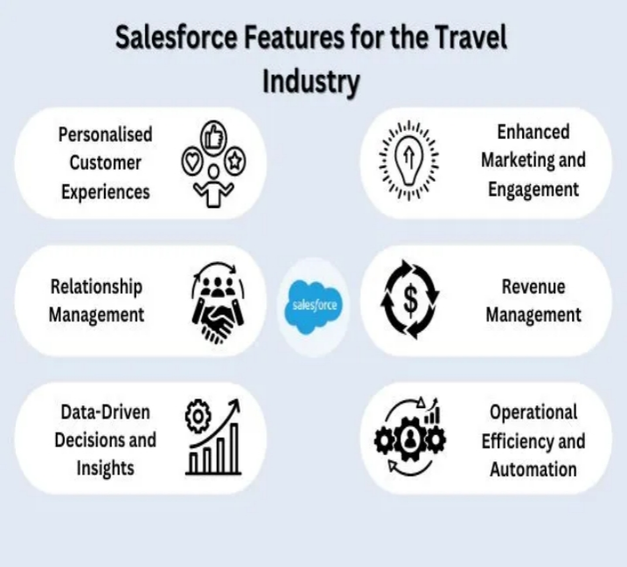

**Brainstorming: Key Modules & Ideas**

|  |  |  |  |
| --- | --- | --- | --- |
| **Module** | **Ideas / Features** | **Priority** | **Salesforce Tools** |
| **Customer Management** | 360° customer profile, frequent flyer data, preferences | 🔥 High | Sales Cloud, Service Cloud |
| **Ticket Booking System** | Integrate online booking, PNR management | 🔥 High | Custom Objects, Flows |
| **Flight Scheduling** | Aircraft rotation, crew schedule, delay management | 🟡 Medium | Custom Apps |
| **Revenue Management** | Dynamic pricing, demand forecasting | 🔥 High | Einstein Analytics |
| **Loyalty Program (Miles)** | Miles tracking, tier levels, redemption | 🔥 High | Loyalty Management |
| **Customer Service (Support)** | Omnichannel support, chatbot, case routing | 🔥 High | Service Cloud, Einstein Bot |
| **Marketing Automation** | Email campaigns, offers, segmentation | 🟢 Low | Marketing Cloud |
| **Mobile App Integration** | Ticket alerts, QR boarding passes | 🟡 Medium | Mobile SDK, API Integration |
| **B2B Corporate Accounts** | Manage travel agent/enterprise bookings | 🟡 Medium | Account Hierarchies |
| **Feedback & Surveys** | In-flight and post-travel survey automation | 🟢 Low | Survey Tool, Flow Builder |

**Prioritization Matrix**

|  |  |
| --- | --- |
| **Priority** | **Features** |
| **High** | Customer Management, Booking System, Revenue Mgmt, Loyalty, Support |
| **Medium** | Flight Scheduling, B2B Bookings, Mobile App |
| **Low** | Feedback System, Marketing Campaigns |

**Visual: Salesforce Airline Project Architecture**

Here's a conceptual diagram (created below) to help illustrate how the system might connect.

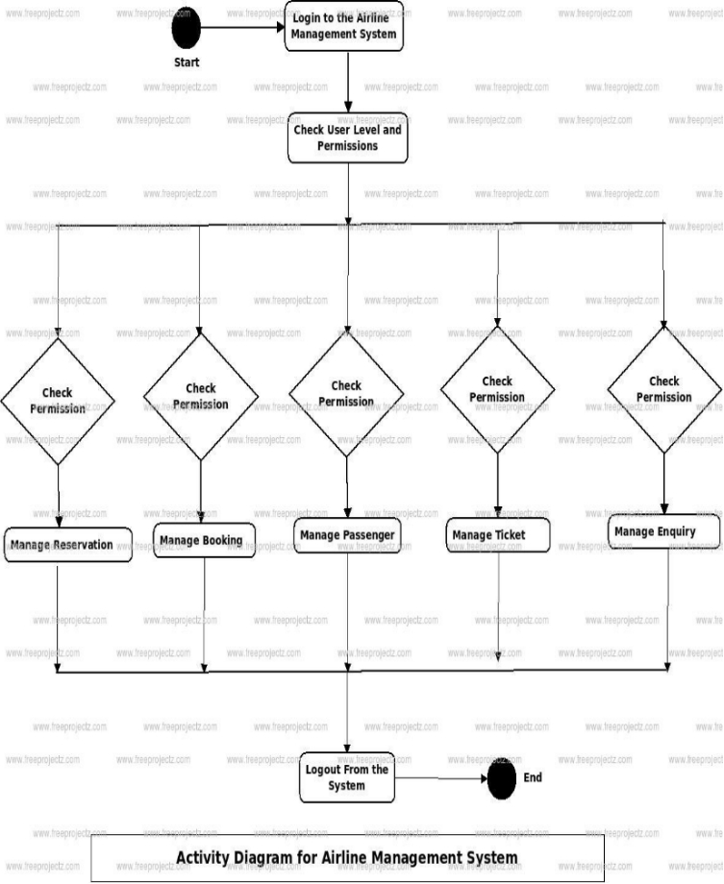

**Suggested Project Flow (with visual stages)**

1. Discovery & Requirement Gathering

↓

2. Data Model Design (Flights, Tickets, Customers)

↓

3. Custom App Development (Booking, Loyalty, etc.)

↓

4. Integration (Payment Gateway, Mobile App, APIs)

↓

5. Testing (UAT, Load, Security)

↓

6. Deployment on Salesforce

↓

7. Training & Go-Live

**Tools for Implementation**

* **Salesforce Clouds**: Sales Cloud, Service Cloud, Marketing Cloud, Loyalty Management
* **Integration**: REST APIs, MuleSoft, Mobile SDK
* **Automation**: Flow Builder, Apex, Process Builder
* **Analytics**: Tableau CRM (Einstein)

**2.2 Empathy Map :**

An empathy map is a simple, easy-to-digest visual that captures knowledge about a user’s behaviours and attitudes.

An **Empathy Map** is a collaborative tool used to gain deeper insight into users' needs and experiences. For the **Salesforce-based Airline Management System project**, it helps understand the pain points, thoughts, and behavior of stakeholders like passengers, customer support agents, and operations staff.

**Example:**

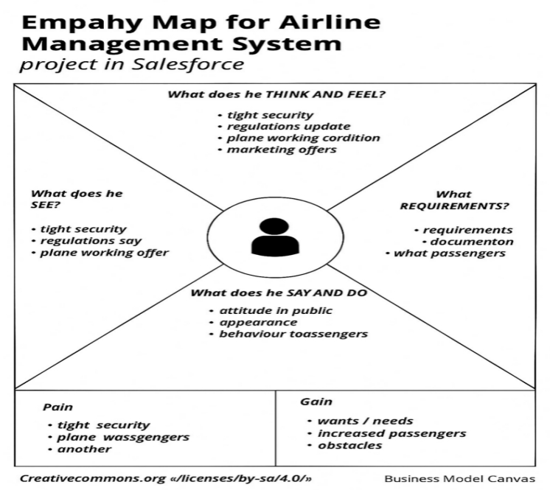

Reference: <https://www.mural.co/templates/empathy-map-canvas>

**Example: Journey Experiencing**

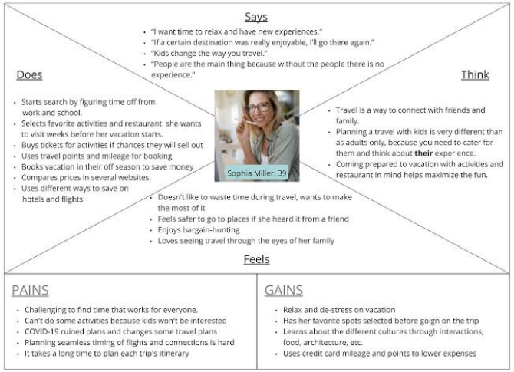

**2.3 The Problem Statemen**

**Customer Problem Statement :**

A **Customer Problem Statement** helps define the key pain points from the passenger’s perspective, enabling better design and implementation of Salesforce-based solutions that enhance the customer experience.

In today’s digital-first world, customers expect fast, seamless, and personalized service—especially when it comes to air travel. However, many airlines still rely on outdated or disconnected systems that create friction at every stage of the passenger journey. The Salesforce platform offers a modern, integrated solution to transform the customer experience.

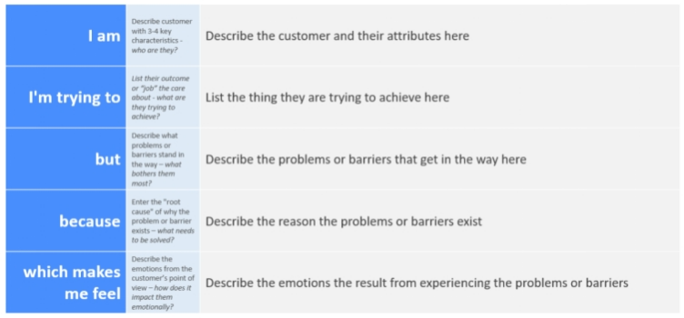

Reference: <https://miro.com/templates/customer-problem-statement/>

**Example:**



|  |  |  |  |  |  |
| --- | --- | --- | --- | --- | --- |
| **Problem Statement (PS)** | **I am (Customer)** | **I’m trying to** | **But** | **Because** | **Which makes me feel** |
| PS-1 | a frequent airline passenger who books and manages travel online. | search flights, book tickets, check status, and get help easily. | the service is inconsistent across the website, app, and support. | the systems are not connected and lack real-time updates. | frustrated, ignored, and anxious about the reliability of my travel plans. |
| PS-2 | a passenger who needs quick help when there’s a flight delay or issue. | contact support and get updates without long wait times. | I often face delays, get unclear answers, or need to repeat my problem. | there’s no single system that tracks my history or provides real-time info. | helpless, annoyed, and less likely to trust the airline. |

**Problem Statement (Passenger)**

I am a passenger who frequently travels by air.

I’m trying to book flights quickly, check real-time flight updates, and manage my travel plans seamlessly.

But the current airline systems are often confusing, slow, and lack proper coordination between booking, check-in, and updates.

Because they are outdated, fragmented, and not optimized for user experience.

Which makes me feel frustrated, uncertain, and dissatisfied with the service.

**Problem Statement (Airline Staff / Administrator)**

I am an airline operations staff member responsible for managing flight schedules, bookings, and customer service.

I’m trying to coordinate daily operations, ensure timely updates, manage crew schedules, and respond to customer queries efficiently.

But the current system lacks integration, is prone to delays and errors, and doesn’t provide real-time information.

Because different departments use disconnected tools, and manual processes are still heavily relied upon.

Which makes me feel stressed, overburdened, and unable to provide a smooth and reliable service to passengers.

**3.REQUIREMENT ANALYSIS:**

The Airline Management System (AMS) is designed to manage all operations related to airline services such as flight scheduling, ticket booking, crew management, customer management, and more. The system ensures efficiency, security, and convenience for both airline staff and customers.

**3.1 CUSTOMER JOURNEY MAP**

Customer Journey Map – Airline Management System

|  |  |  |  |  |  |
| --- | --- | --- | --- | --- | --- |
| Stage | Customer Actions | Touchpoints | Customer Thoughts & Feelings | Opportunities for Improvement | Salesforce Support |
| 1. Awareness | Searches for flights, sees ads, word-of-mouth | Social media, website, travel blogs, email ads | "I need to find a reliable airline." | Personalized marketing, SEO optimization | Marketing Cloud: targeted campaigns & analytics |
| 2. Consideration | Compares prices, routes, services | Airline website, travel apps, online reviews | "Which airline gives me the best value?" | Transparent pricing, customer testimonials | CRM data for personalized offers |
| 3. Booking | Selects flight, enters personal info, makes payment | Website, mobile app, customer care | "Is this secure? Did I choose the right flight?" | Simplified UI, secure payment gateway, loyalty perks | Service Cloud & Salesforce Payments Integration |
| 4. Pre-Travel | Gets confirmation, checks in, chooses seats | Email, SMS, mobile app, chatbot | "Am I ready to fly? Where’s my gate?" | Proactive notifications, mobile check-in | Salesforce Flow for automated updates |
| 5. Travel | Arrives at airport, boards, takes flight | Airport kiosk, boarding gate, flight crew | "Hope everything goes smoothly." | Real-time gate info, customer support on-site | Mobile apps, IoT integration, Live Agent |
| 6. Post-Travel | Feedback, claims, reward points, rebooking | Email survey, app, support portal | "How was my overall experience?" | Loyalty rewards, easy complaints, quick refunds | Experience Cloud for feedback, Loyalty Cloud |
| 7. Retention | Receives offers, joins loyalty program, books again | Email, app, SMS | "Should I fly with them again?" | Personalized deals, thank-you emails, loyalty tier | Journey Builder + Einstein AI for tailored offers |

**3.2 SOUTION REQUIREMENTS:**

**Functional Requirements:**

Following are the functional requirements of the proposed solution.

|  |  |  |
| --- | --- | --- |
| FR No. | Functional Requirement (Epic) | Sub Requirement (Story / Sub-Task) |
| FR-1 | User Management | Register/login passengers, staff, and admins.  Role-based access control (Passengers, Agents, Admins).  Profile updates and account deactivation. |
| FR-2 | Flight Scheduling | Add, update, cancel flights.  Manage flight routes, timings, and aircraft assignments.  Track real-time flight status. |
| FR-3 | Reservation & Booking System | Search flights by date, route, or fare.  Book or modify reservations.  Generate booking confirmation and ticket. |
| FR-4 | Payment Integration | Enable online payments (credit/debit, UPI, wallet).  Generate invoices and track payment history.  Refund and cancellation processing. |
| FR-5 | Customer Relationship Management (CRM) via Salesforce | Store and manage customer interactions.  Track customer preferences and feedback.  Send promotional offers and updates via email/SMS. |
| FR-6 | Check-in & Boarding Management | Online check-in system with seat selection.  Issue boarding passes.  Manage baggage details. |
| FR-7 | Staff & Crew Scheduling | Assign pilots, cabin crew, and ground staff to flights.  View and manage duty rosters.  Track staff availability and performance. |
| FR-8 | Reporting & Analytics | Generate sales, booking, and performance reports.  Analyze customer behavior and operational metrics. |
| FR-8 | Alerts & Notifications | Send reminders (flight status, gate changes, delays).  Real- SMS/email updates to passengers and staff. |

**3.3 Data Flow Diagrams:**

A Data Flow Diagram (DFD) is a traditional visual representation of the information flows within a system. A neat and clear DFD can depict the right amount of the system requirement graphically. It shows how data enters and leaves the system, what changes the information, and where data is stored.

Example:

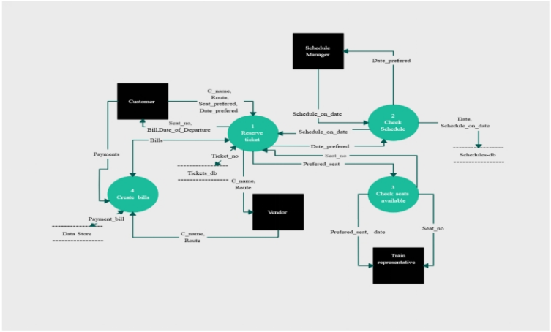

Example:

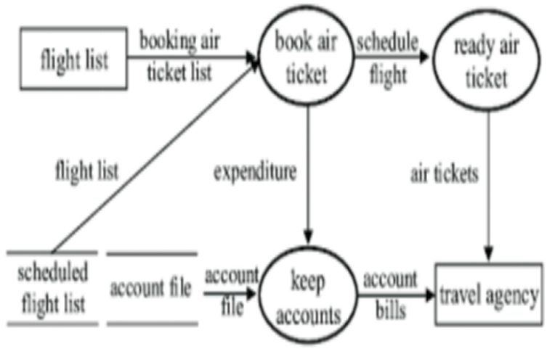

**3.4 Technology Stack (Architecture & Stack)**

**Technical Architecture:**

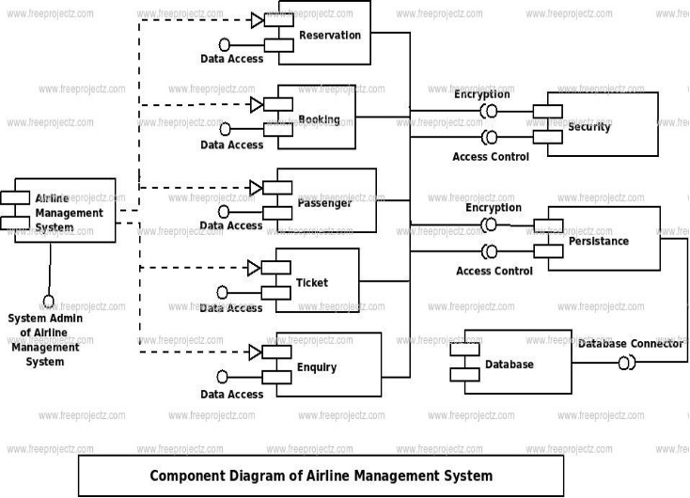

Example: Order processing during pandemics for offline mode

Reference: https://www.mdpi.com/2673-8112/3/1/1

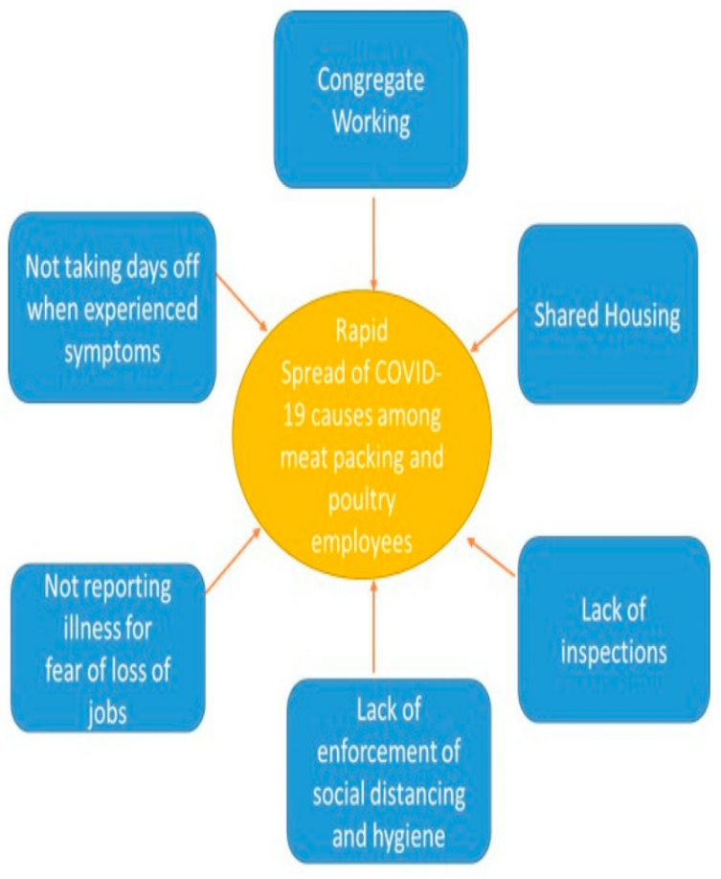

**Table-1 : Components & Technologies:**

**Airline Management System – Components Table**

|  |  |  |  |  |  |  |  |  |  |  |  |  |  |  |  |  |  |  |  |  |  |  |  |  |  |  |  |  |  |  |  |  |  |  |  |  |  |  |  |  |  |  |  |  |  |  |  |  |  |  |  |  |  |  |  |  |  |  |  |  |  |  |  |  |  |  |  |  |  |  |  |  |  |  |  |
| --- | --- | --- | --- | --- | --- | --- | --- | --- | --- | --- | --- | --- | --- | --- | --- | --- | --- | --- | --- | --- | --- | --- | --- | --- | --- | --- | --- | --- | --- | --- | --- | --- | --- | --- | --- | --- | --- | --- | --- | --- | --- | --- | --- | --- | --- | --- | --- | --- | --- | --- | --- | --- | --- | --- | --- | --- | --- | --- | --- | --- | --- | --- | --- | --- | --- | --- | --- | --- | --- | --- | --- | --- | --- | --- | --- |
| |  |  |  | | --- | --- | --- | | **Component** | **Description** | **Technology / Platform** | |  |  |  | | User Interface (UI) | Front-end for passengers, staff, and admins to interact with the system. | HTML, CSS, JavaScript, Salesforce Lightning | | Authentication Module | Manages user login, registration, and roles (passenger, staff, admin). | Salesforce Identity, OAuth 2.0, Apex | |  |  |  | | Flight Management | Admin panel to create, edit, and manage flight schedules and aircrafts. | Apex, SOQL, Salesforce Objects, Lightning UI | | Reservation System | Handles flight search, seat availability, booking, and ticket generation. | Salesforce Service Cloud, Apex | |  |  |  | | Payment Gateway | Processes online payments and refunds securely. | Stripe/PayPal Integration via Salesforce APIs | |  |  |  | | CRM Integration | Maintains customer data, preferences, history, and marketing engagement. | Salesforce Sales Cloud / Marketing Cloud | |  |  |  | | Check-in System | Enables web/mobile check-in, seat selection, and generates boarding passes. | Apex, Lightning Components, QR generation APIs | |  |  |  | | Staff Management | Schedules pilots, cabin crew, and ground staff across flights. | Custom Salesforce App or third-party plugin | |  |  |  | | Notification Engine | Sends alerts and reminders for flight status, offers, etc. | Salesforce Flow, Twilio API, Email Studio | |  |  |  | | Analytics & Reporting | Provides dashboards for bookings, revenue, customer trends, etc. | Salesforce Einstein Analytics / Tableau CRM | |  |  |  | | Mobile Access | Mobile-friendly interface for passengers and staff. | Salesforce Mobile App / React Native | |  |  |  | | Database | Stores user, booking, flight, payment, and feedback data securely. | Salesforce Object Database (SObject), SOQL | |  |  |  | | Security Layer | Protects against unauthorized access and data breaches. | Salesforce Shield, Encryption, | |

**Table-2: Application Characteristics:**

Here’s a comprehensive Application Characteristics Table for an Airline Management System with Salesforce integration:

Application Characteristics Table

|  |  |  |
| --- | --- | --- |
| Characteristic | Description | Technology / Tools |
| Scalability | Ability to handle growing number of users, bookings, and flights. | Salesforce Cloud Platform, Elastic Load Balancers |
| Availability | System should be accessible 24/7 with minimal downtime. | Salesforce High Availability Cloud, Multi-zone Hosting |
| Reliability | Ensures consistent service and accurate data processing. | Salesforce Platform, Redundancy Mechanisms |
| Security | Protects user data, prevents unauthorized access and breaches. | Salesforce Shield, Encryption, OAuth 2.0, 2FA |
| Usability | Easy and intuitive interface for all types of users. | Salesforce Lightning Design System (SLDS), Mobile-first UI |
| Performance | Fast response times for booking, check-in, and search operations. | Apex Optimization, Asynchronous Processing, Caching |
| Maintainability | Ease of updates, bug fixes, and feature additions. | Modular Apex Code, Salesforce DX, Git CI/CD |
| Integration | Seamless connection with payment, email, SMS, and CRM services. | REST APIs, SOAP APIs, Salesforce AppExchange |
| Portability | Usable across web and mobile devices. | Salesforce Mobile SDK, Responsive Web Design |
| Customizability | Easy to configure workflows, business logic, and UI based on airline needs. | Salesforce Flows, Apex Triggers, Lightning Components |
| Auditability | Tracks user activity and system changes for compliance. | Salesforce Field History Tracking, Audit Trail |
| Analytics Capability | Real-time and historical insights into bookings, performance, and behavior. | Salesforce Einstein Analytics, Reports & Dashboards |

**4.PROJECT DESIGN**

**4.1 PROBLEM SOLUTION FIT :**

The Problem-Solution Fit simply means that you have found a problem with your customer and that the solution you have realized for it actually solves the customer’s problem. It helps entrepreneurs, marketers and corporate innovators identify behavioral patterns and recognize what would work and why

**Purpose:**

Solve complex airline operations challenges by aligning Salesforce solutions (like Sales Cloud, Service Cloud, Marketing Cloud) with real-world passenger and staff needs.

Improve solution adoption and speed of service by integrating with platforms customers already use — like mobile, email, and chat — through Salesforce Experience Cloud and Marketing Cloud.

Sharpen communication and support workflows using Service Cloud and Einstein AI, ensuring the right messages reach the right passengers at the right time.

Increase customer engagement and satisfaction by solving frequent issues like delayed updates, disconnected services, and poor support — with automated case routing, live dashboards, and unified customer profiles.

Gain deep understanding of current customer experiences and operational gaps through real-time reports and analytics in Salesforce, enabling continuous improvement.

**Template:**

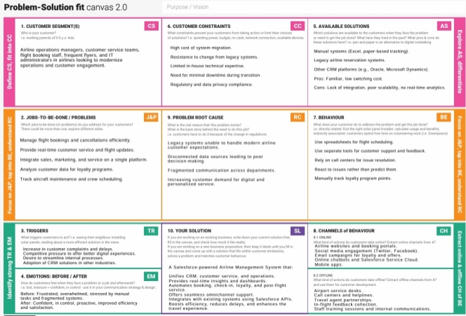

**References:**

1. [**https://www.ideahackers.network/problem-solution-fit-canvas/**](https://www.ideahackers.network/problem-solution-fit-canvas/)

**4.2 Proposed Solution :**

|  |  |  |
| --- | --- | --- |
| **S .No** | **Parameter** | **Description** |
|  | Problem Statement (Problem to be solved) | Airlines need a unified system to fix slow service, poor support, and disconnected operations — improving speed, visibility, and customer satisfaction. |
|  | Idea / Solution description | Build a Salesforce-based system to streamline bookings, automate support, and deliver real-time updates—enhancing passenger experience and airline efficiency. |
|  | Novelty / Uniqueness | Integrates multiple Salesforce clouds into one seamless platform for airlines—offering real-time service, AI-driven support, and a unified customer view. |
|  | Social Impact / Customer Satisfaction | Improves travel experience with faster service, better communication, and higher customer trust—leading to greater satisfaction and loyalty. |
|  | Business Model (Revenue Model) | Revenue is generated through ticket sales, add-on services, and improved retention via personalized marketing powered by Salesforce. |
|  | Scalability of the Solution | Built on Salesforce Cloud, the solution easily scales to support more users, flights, and features without compromising performance. |

**4.3 Solution Architecture:**

The solution uses **Salesforce’s cloud ecosystem** to create a fully integrated airline management platform that streamlines passenger services, operations, and communication.

* **360° Customer View**  
  Centralize traveler data from booking to post-flight, enabling better service and personalization..
* **Automation of Airline Operations**  
  Automate frequent tasks like ticket reissuance, flight reminders, delay alerts, etc.
* **Scalability and Flexibility**  
  Easily scale operations across routes, regions, and customer segments without rebuilding the system.
* **Enhanced Customer Experience**  
  Faster issue resolution, personalized travel suggestions, real-time updates, and loyalty tracking.

**Example - Solution Architecture Diagram:**

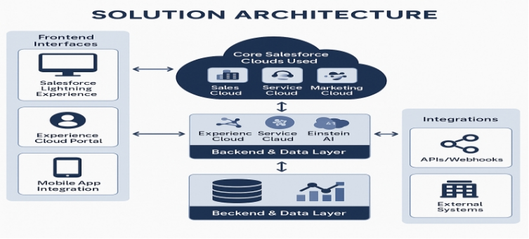

*Figure 1: Architecture for Airline Management System Project.*

**Reference:** [**https://aws.amazon.com/blogs/industries/voice-applications-in-clinical-research-powered-by-ai-on-aws-part-1-architecture-and-design-considerations/**](https://aws.amazon.com/blogs/industries/voice-applications-in-clinical-research-powered-by-ai-on-aws-part-1-architecture-and-design-considerations/)

**5.PROJECT PLANNING & SCHEDULING:**

**Product Backlog, Sprint Schedule, and Estimation**

|  |  |  |  |  |
| --- | --- | --- | --- | --- |
| **Sprint** | **Functional Requirement (Epic)** | **User Story Number** | **User Story / Task** | **Story Points** |
| **Sprint-1** | **Flight Booking** | **USN-1** | **As a user, I can search and view available flights based on date and destination.** | **3** |
| **Sprint-1** | **Flight Booking** | **USN-2** | **As a user, I can book a selected flight and receive a confirmation email.** | **3** |
| **Sprint-2** | **User Management** | **USN-3** | **As an admin, I can add, edit, or delete user profiles.** | **2** |
| **Sprint-2** | **Payment Integration** | **USN-4** | **As a user, I can pay for flights using a credit card or UPI.** | **3** |
| **Sprint-3** | **Flight Management** | **USN-5** | **As an admin, I can add or remove flight schedules in the system.** | **2** |
| **Sprint-3** | **Booking History** | **USN-6** | **As a user, I can view my past and upcoming bookings.** | **2** |
| **Sprint-4** | **Check-In System** | **USN-7** | **As a user, I can check in online and download my boarding pass.** | **2** |
| **Sprint-4** | **Dashboard** | **USN-8** | **As an admin, I can view system statistics and booking analytics.** | **2** |
| **Sprint-5** | **Role-Based Access Control (RBAC)** | **USN-9** | **As a system, I can restrict access based on user roles (admin, customer, agent).** | **3** |
| **Sprint-5** | **Cancellation** | **USN-10** | **As a user, I can cancel my booked flight and receive a refund confirmation.** | **3** |

**Project Tracker, Velocity & Burndown Chart: (4 Marks)**

|  |  |  |  |  |  |
| --- | --- | --- | --- | --- | --- |
| **Sprint** | **Total Story Points** | **Duration** | **Sprint Start Date** | **Sprint End Date (Planned)** | **Sprint Release Date (Actual)** |
| **Sprint-1** | **20** | **2 Days** | **17 Jun 2025** | **18 Jun 2025** | **17 Jun 2025** |
| **Sprint-2** | **20** | **2 Days** | **19 Jun 2025** | **20 Jun 2025** | **19 Jun 2025** |
| **Sprint-3** | **20** | **2 Days** | **21 Jun 2025** | **22 Jun 2025** | **21 Jun 2025** |
| **Sprint-4** | **20** | **2 Days** | **23 Jun 2025** | **24 Jun 2025** | **23 Jun 2025** |
| **Sprint-5** | **20** | **2 Days** | **25 Jun 2025** | **26 Jun 2025** | **25 Jun 2025** |

**Velocity:**

**Imagine we have a 10-day sprint duration, and the velocity of the team is 20 (points per sprint). Let’s calculate the team’s average velocity (AV) per iteration unit (story points per day)**

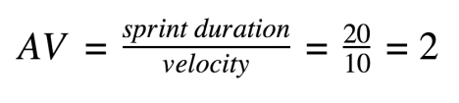

**Burndown Chart:**

**A burn down chart is a graphical representation of work left to do versus time. It is often used in agile** [**software development**](https://www.visual-paradigm.com/scrum/what-is-agile-software-development/) **methodologies such as** [**Scrum**](https://www.visual-paradigm.com/scrum/scrum-in-3-minutes/)**. However, burn down charts can be applied to any project containing measurable progress over time.**

[**https://www.visual-paradigm.com/scrum/scrum-burndown-chart/**](https://www.visual-paradigm.com/scrum/scrum-burndown-chart/)

[**https://www.atlassian.com/agile/tutorials/burndown-charts**](https://www.atlassian.com/agile/tutorials/burndown-charts)

**6.PROJECT DEVELOPMENT**

**6.1 OUTPUT SCREENSHOTS**

**Account Creating and Activating**

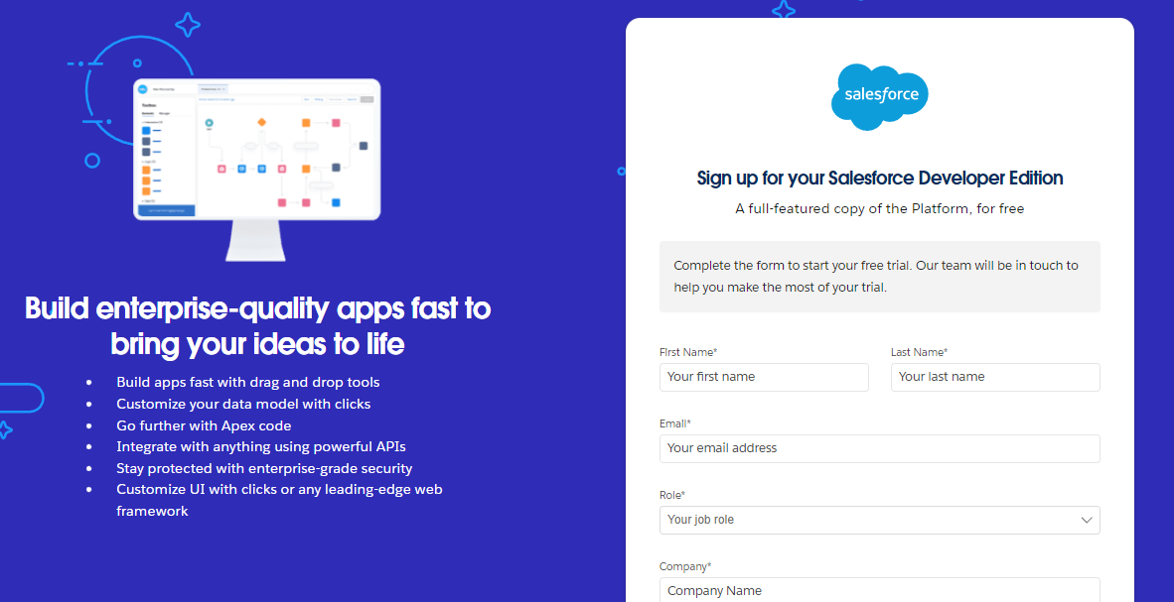

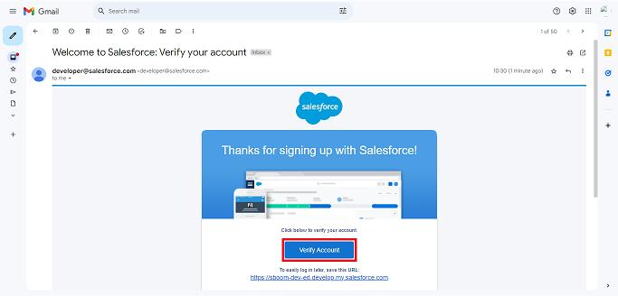

**Objects created**

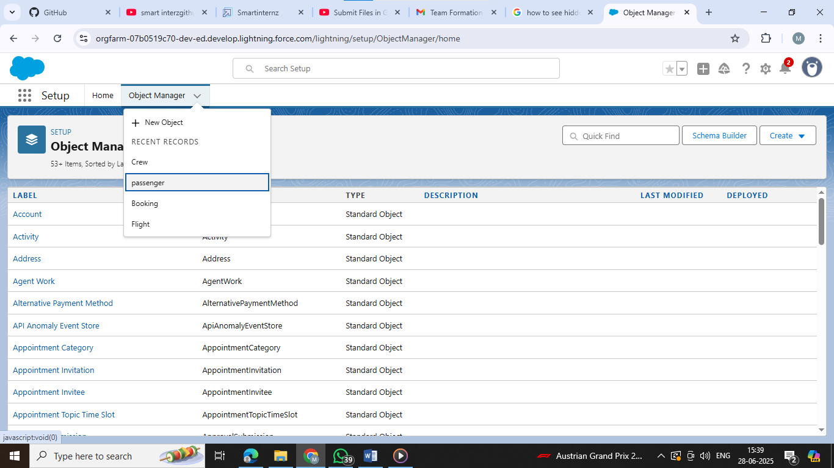

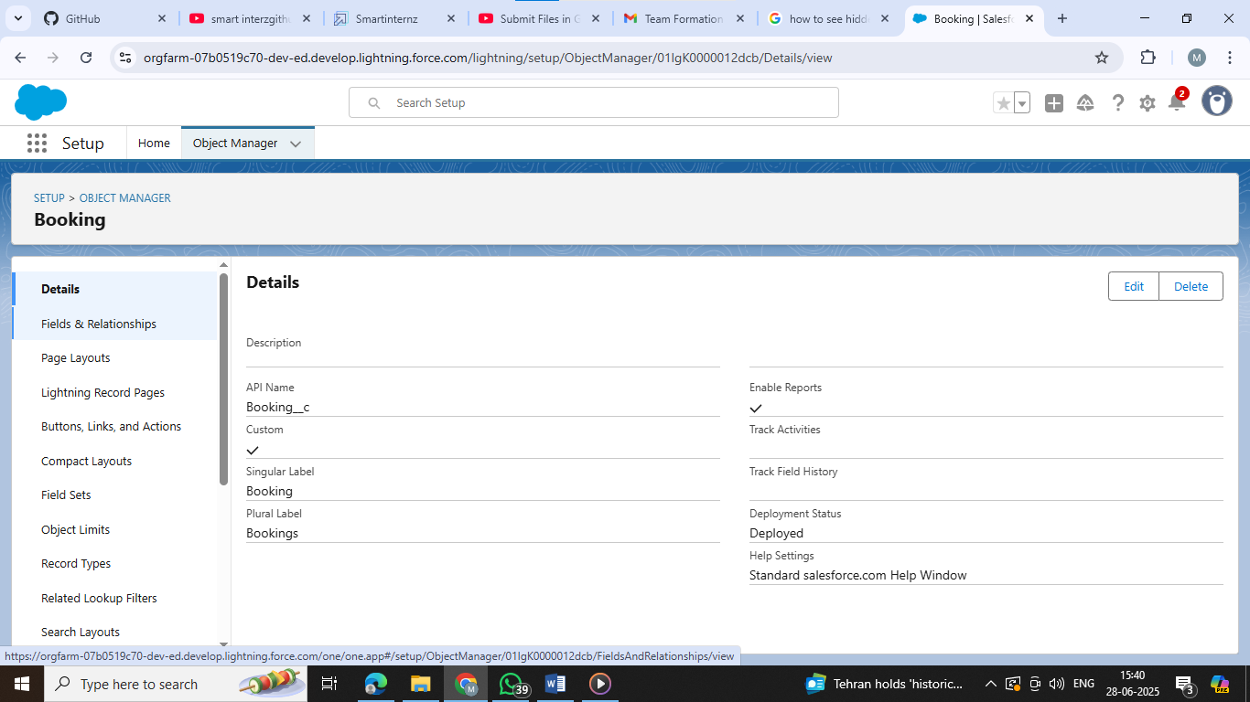

**Creating of custom Tabs**

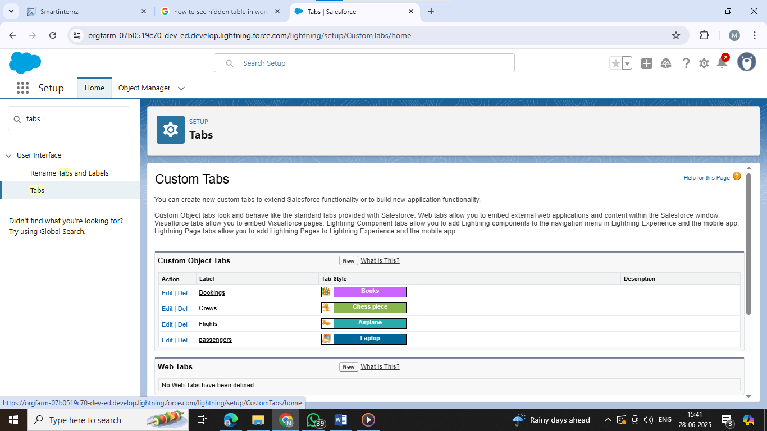

**Lightening App created**

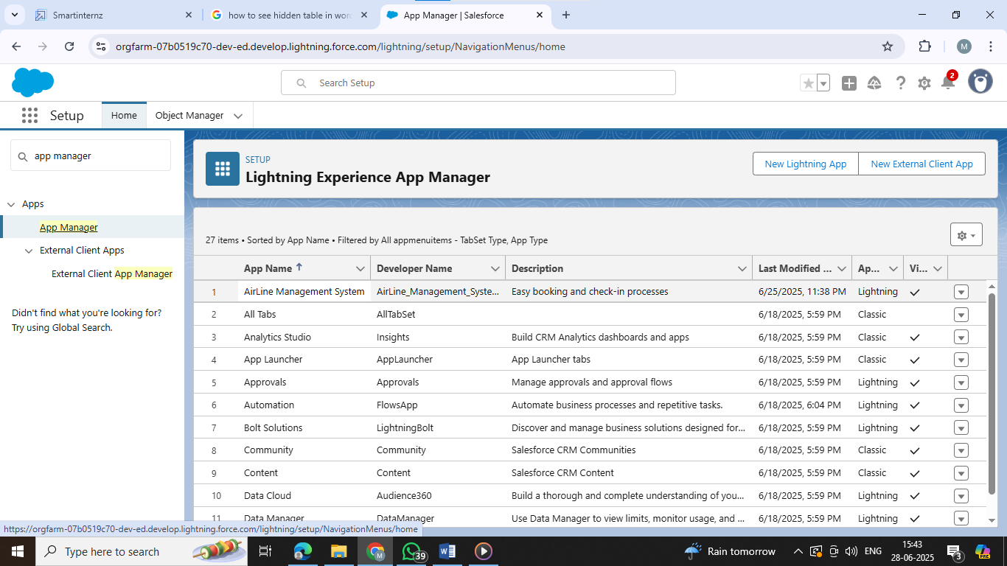

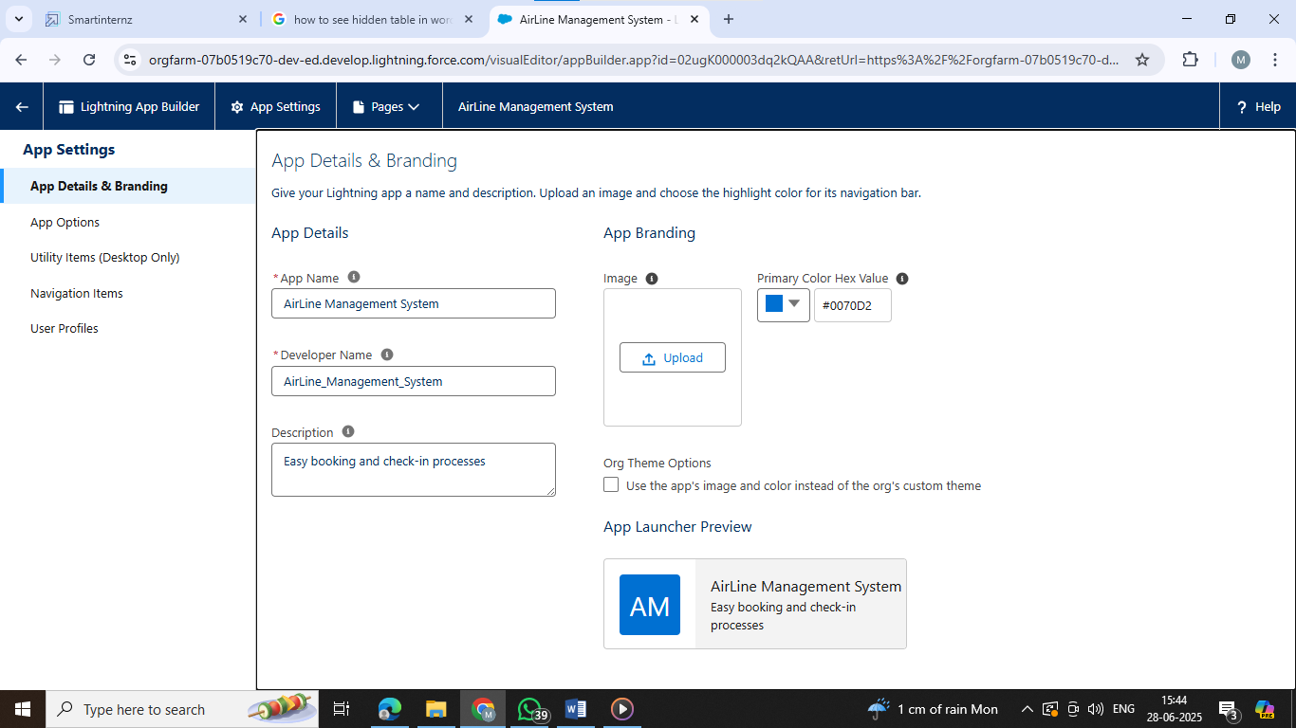

**Created different Fields in every object**

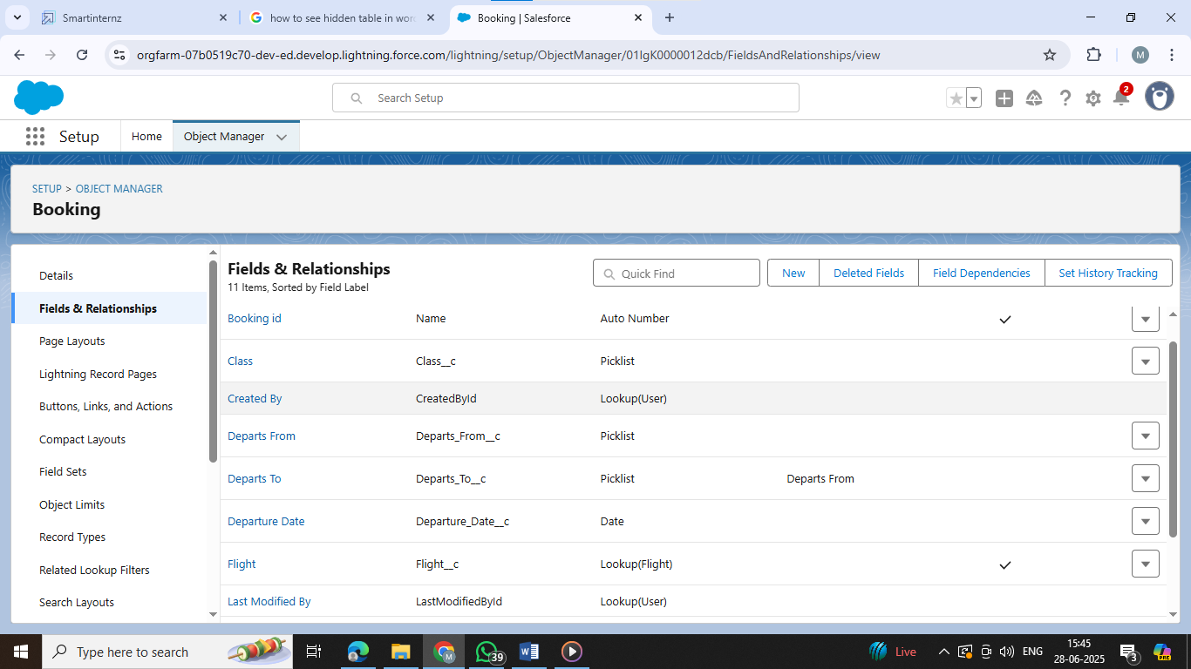

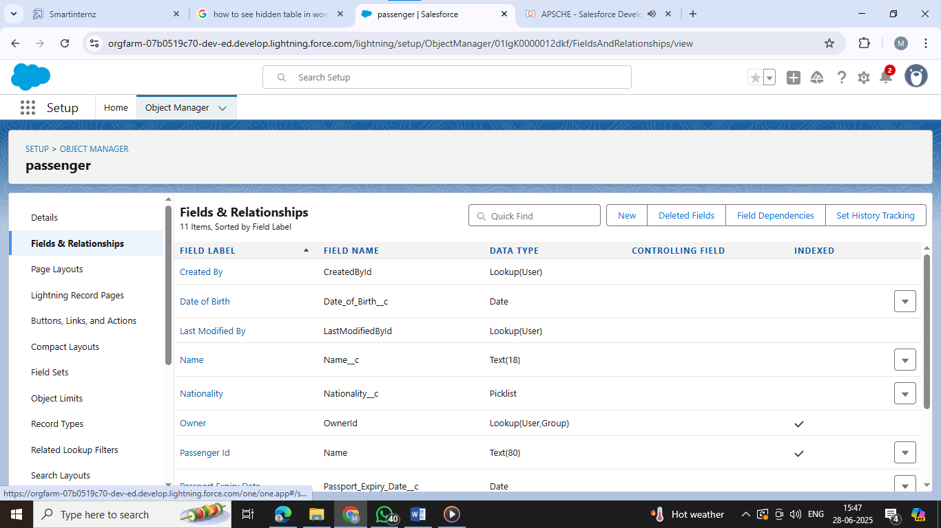

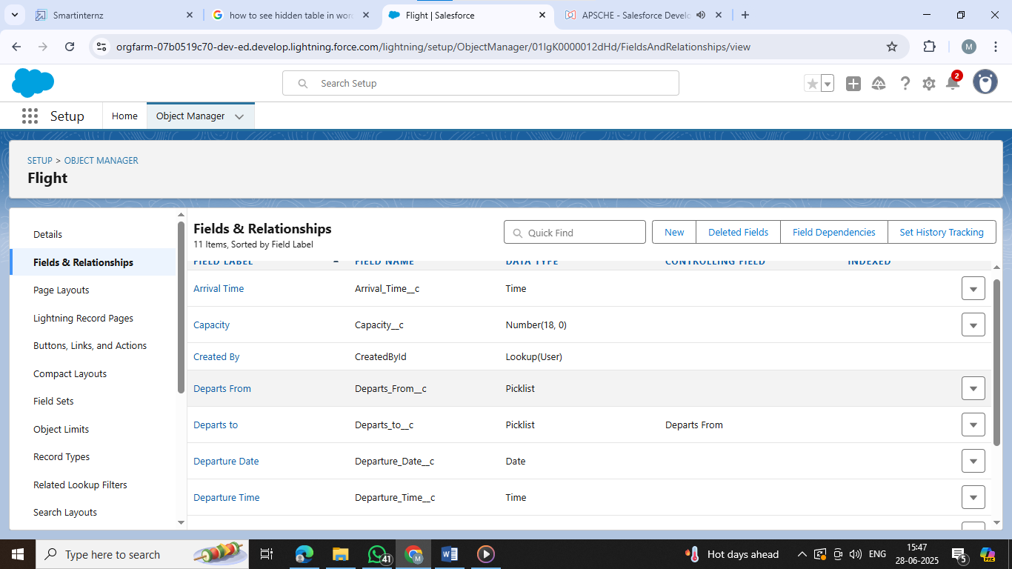

### Schema Builder

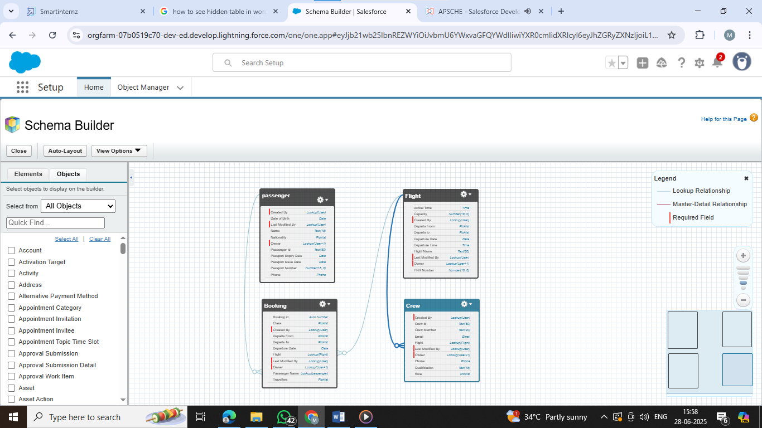

**Records**

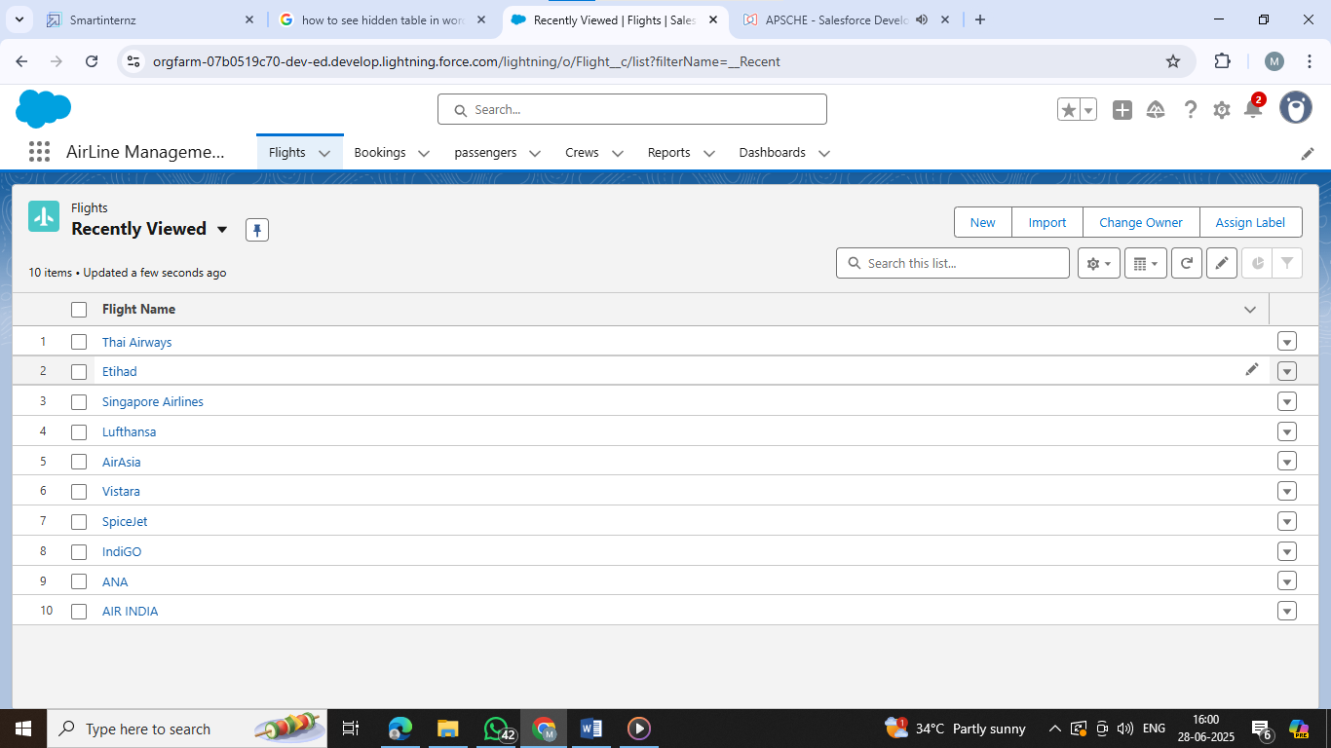

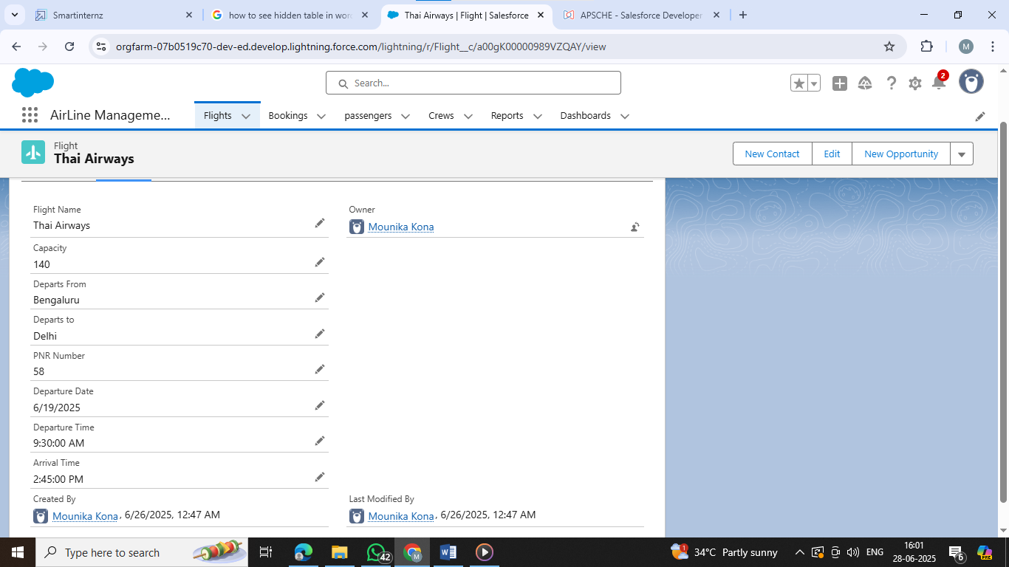

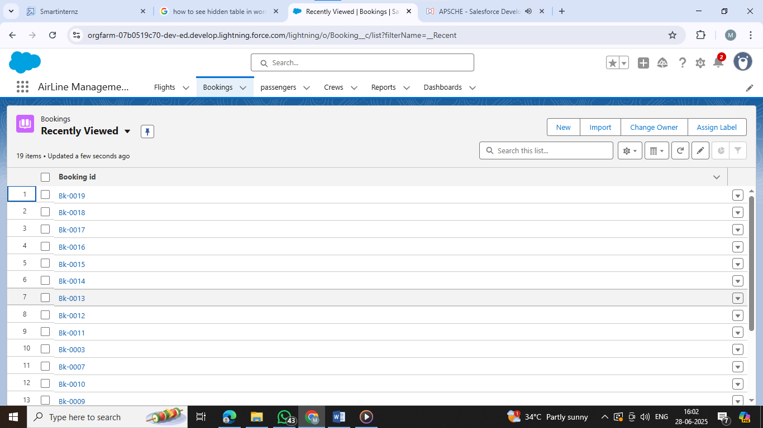

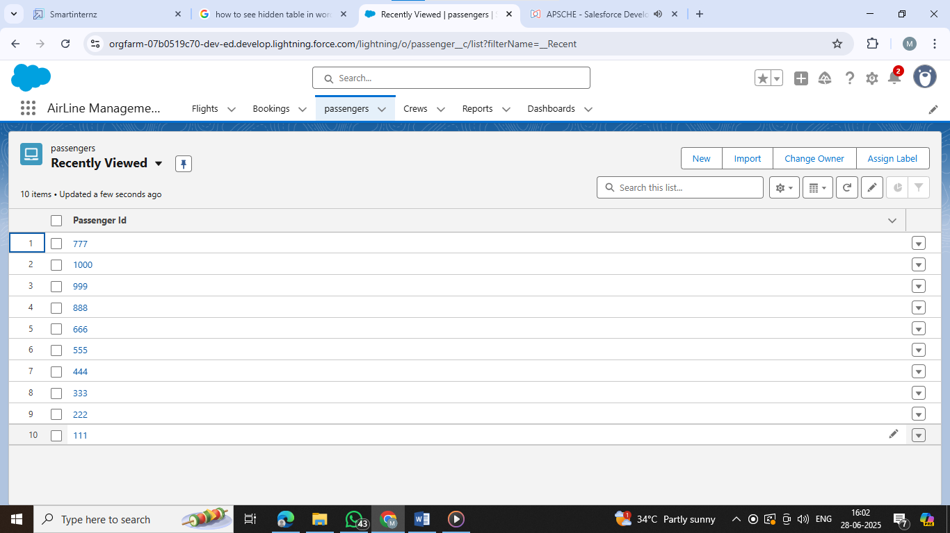

**Profiles**

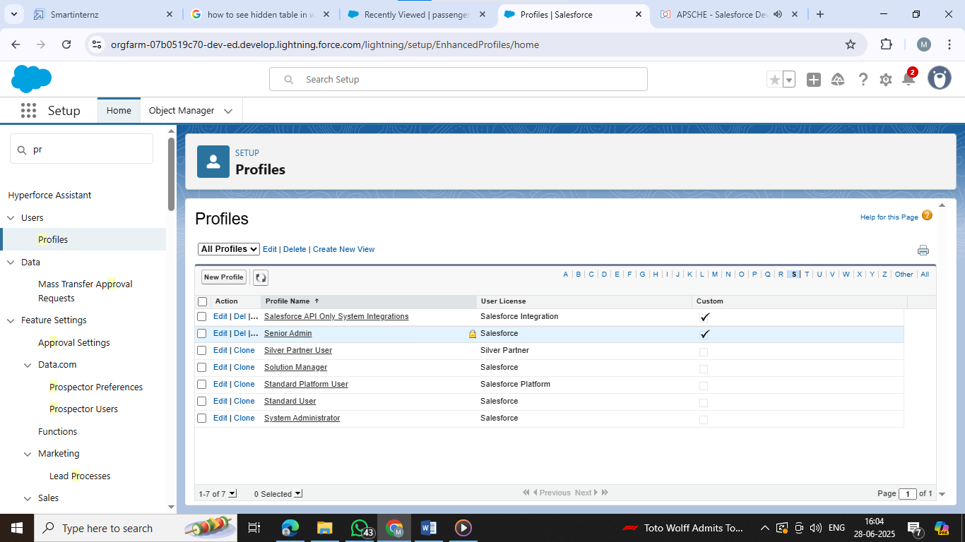

**Roles**

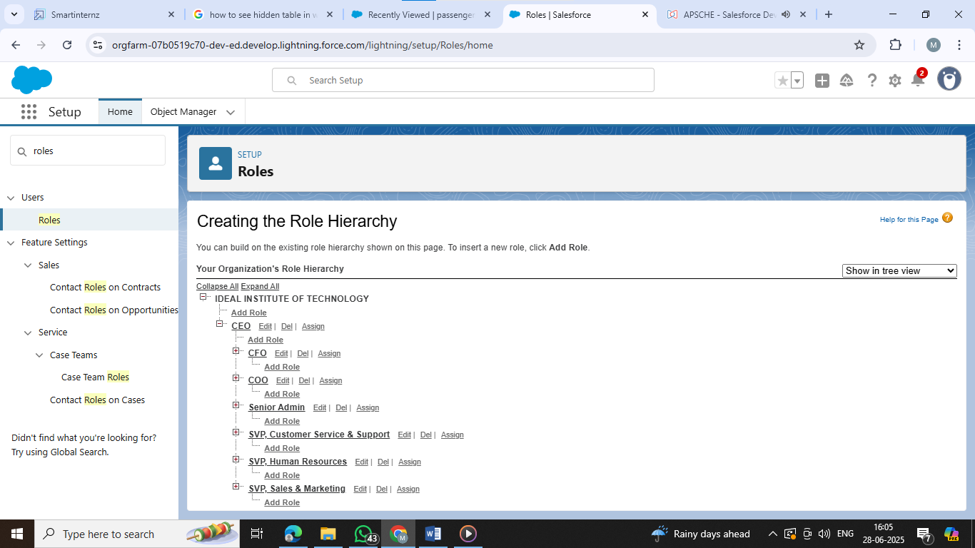

**Users**

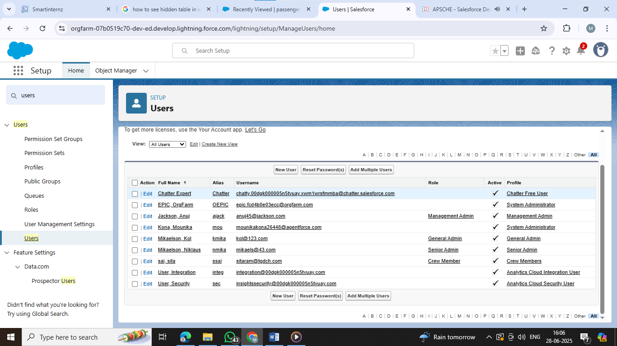

**Reports**

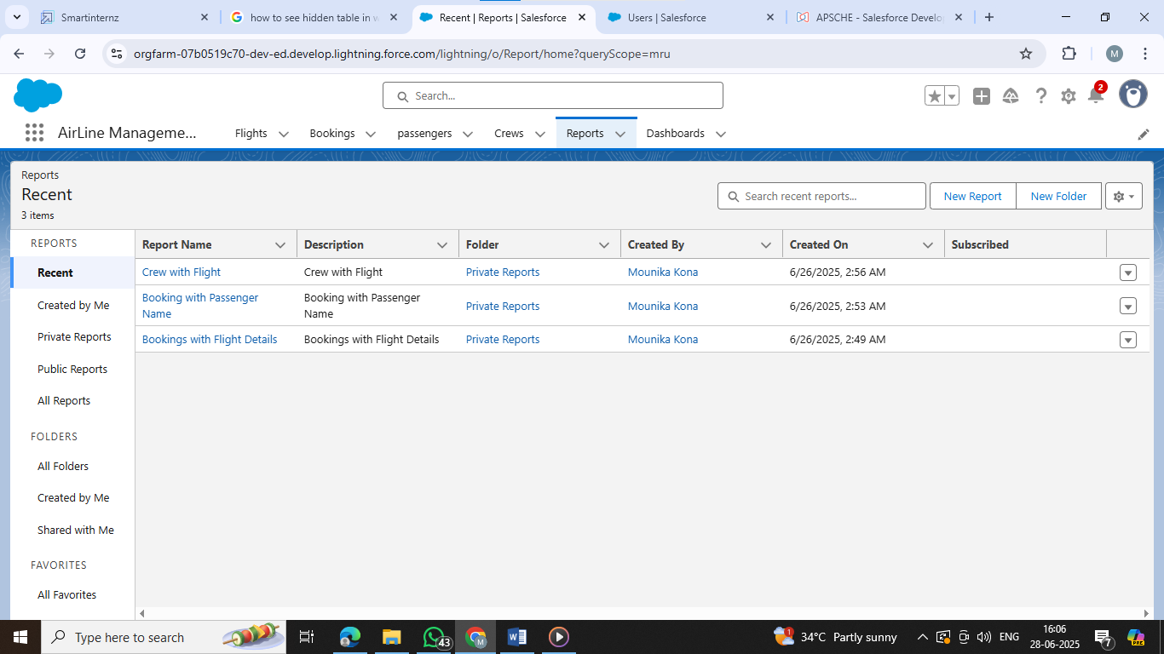

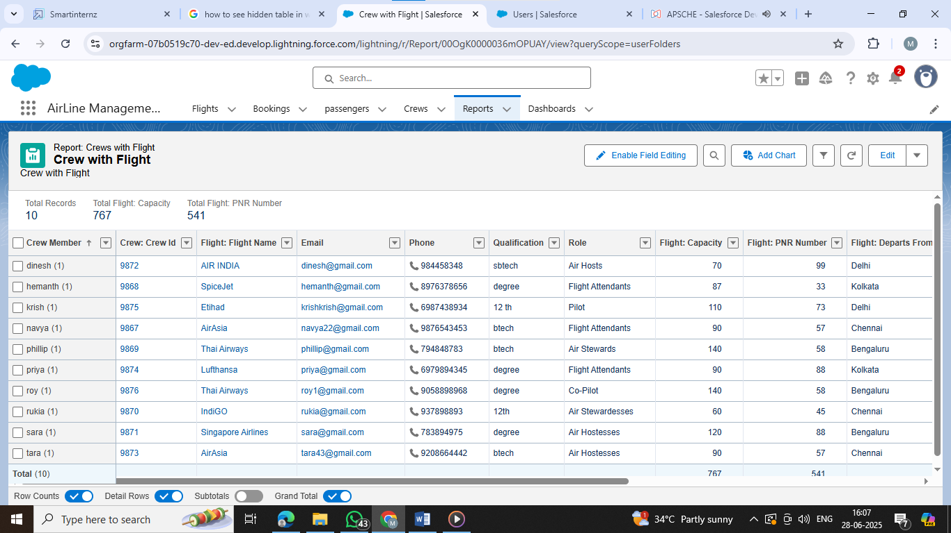

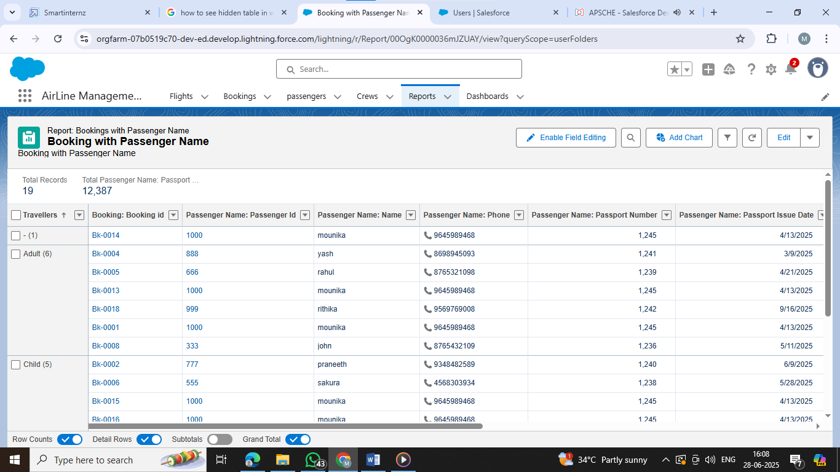

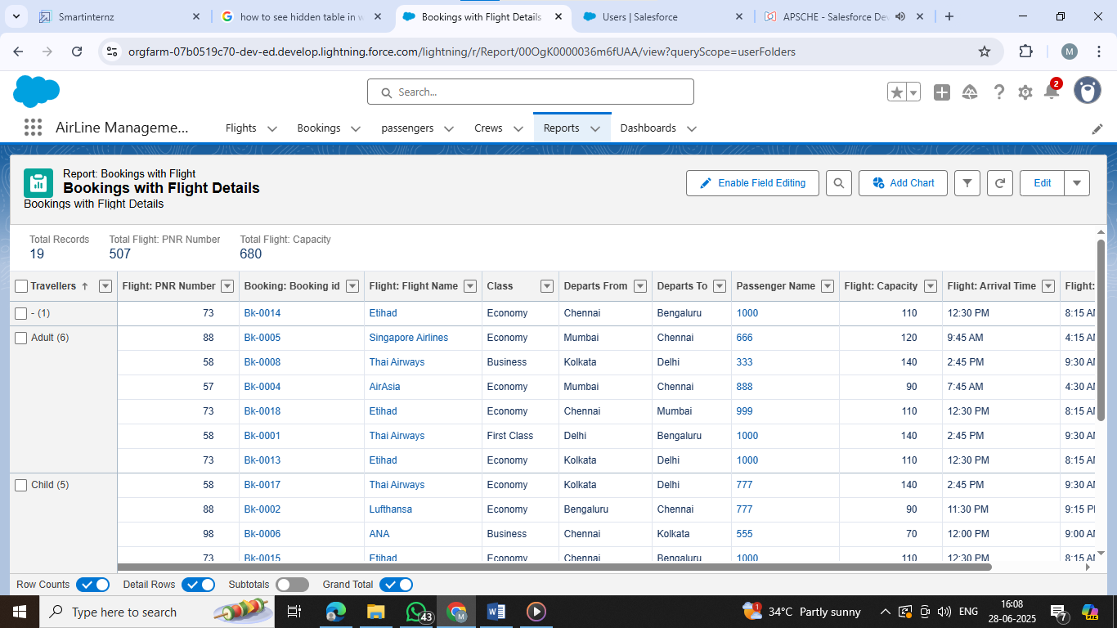

**Dashboards**

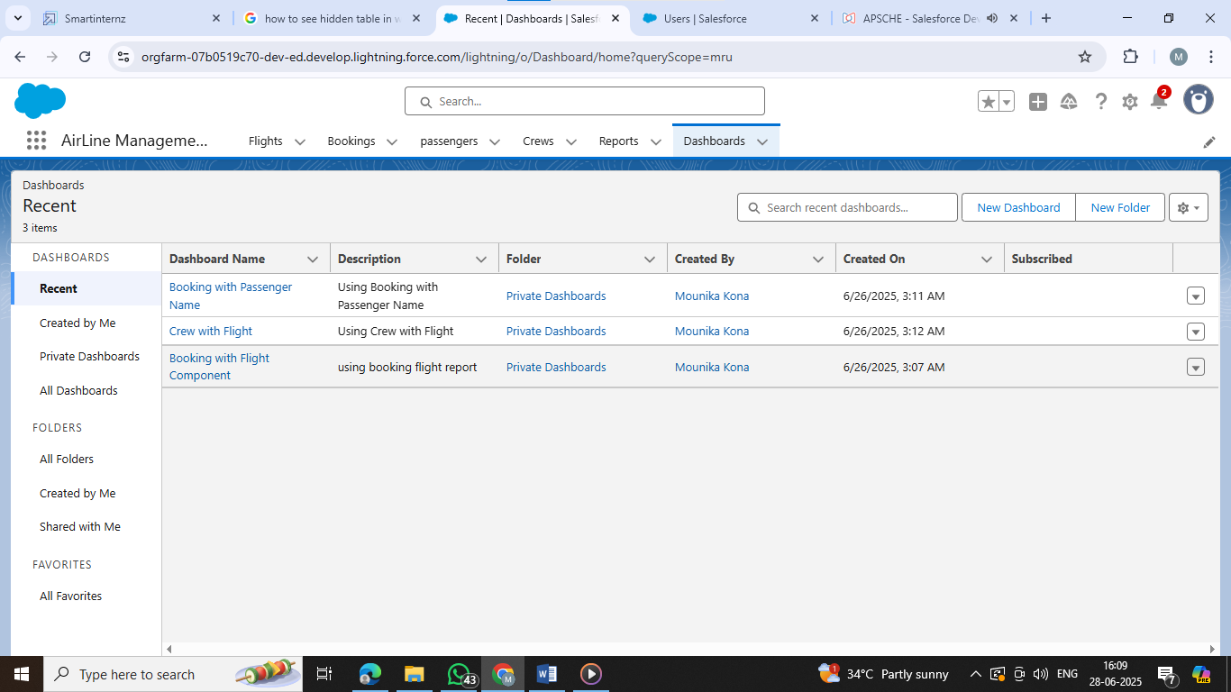

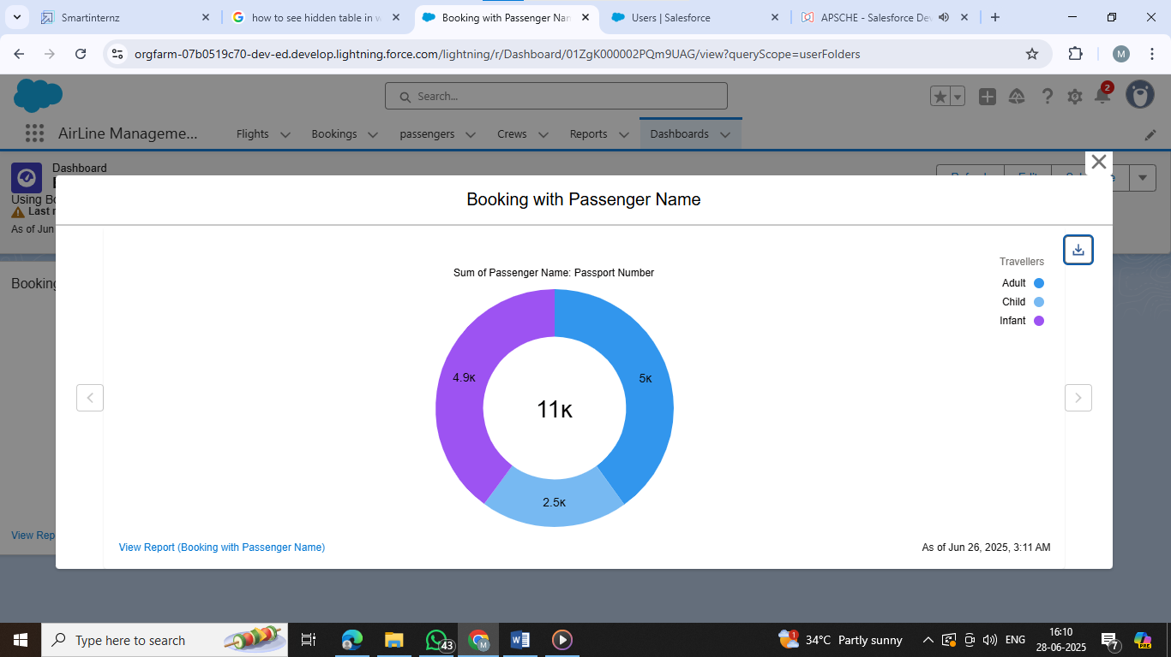

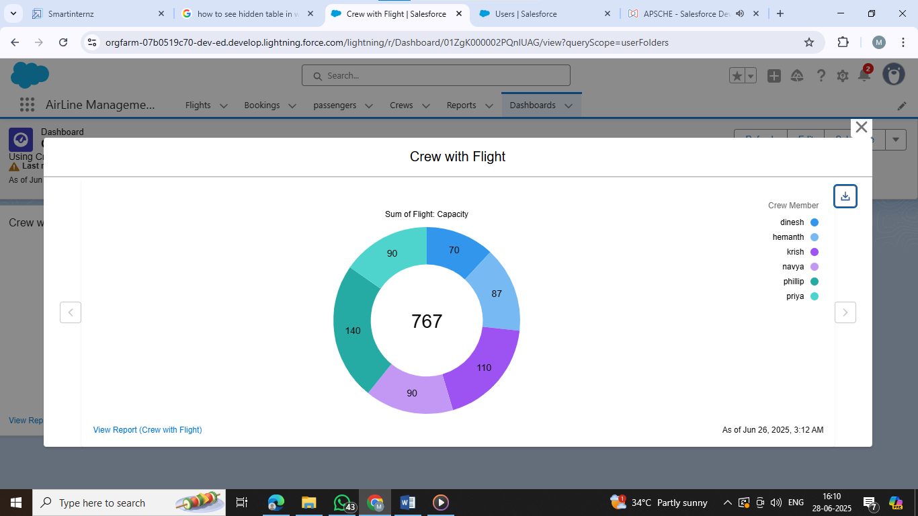

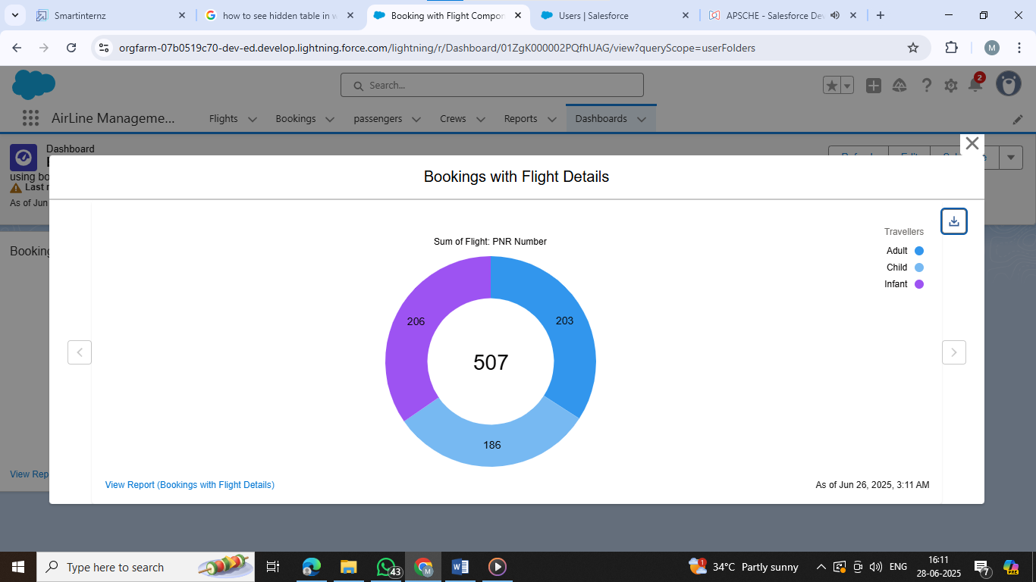

### Apex Class

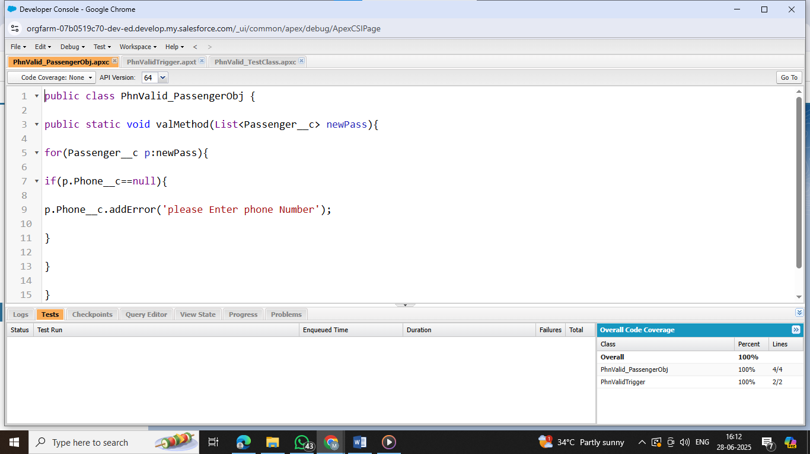

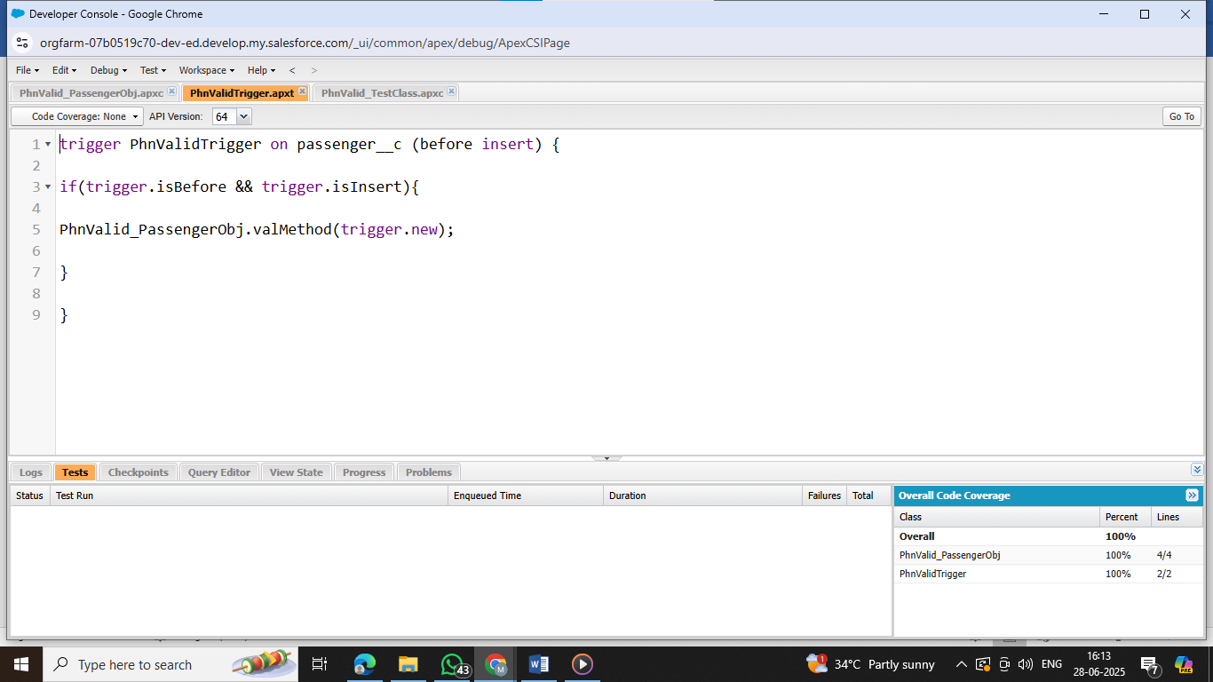

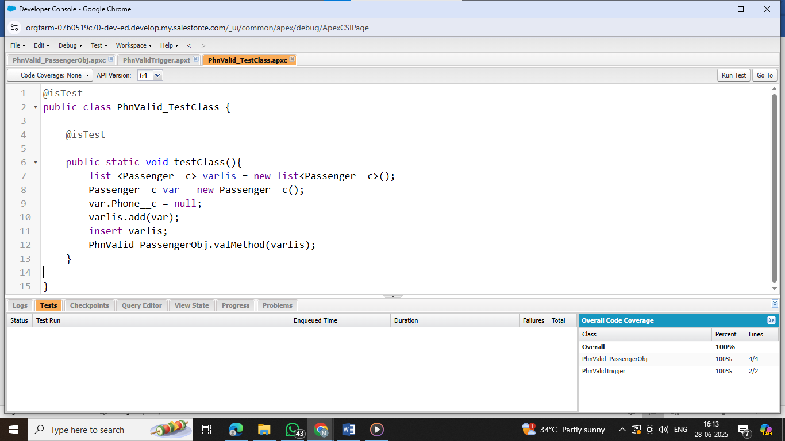

**Flows**

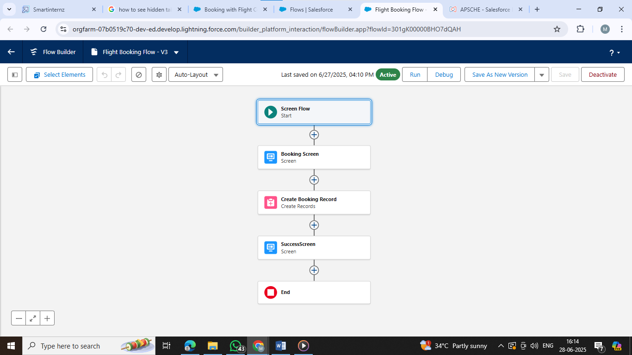

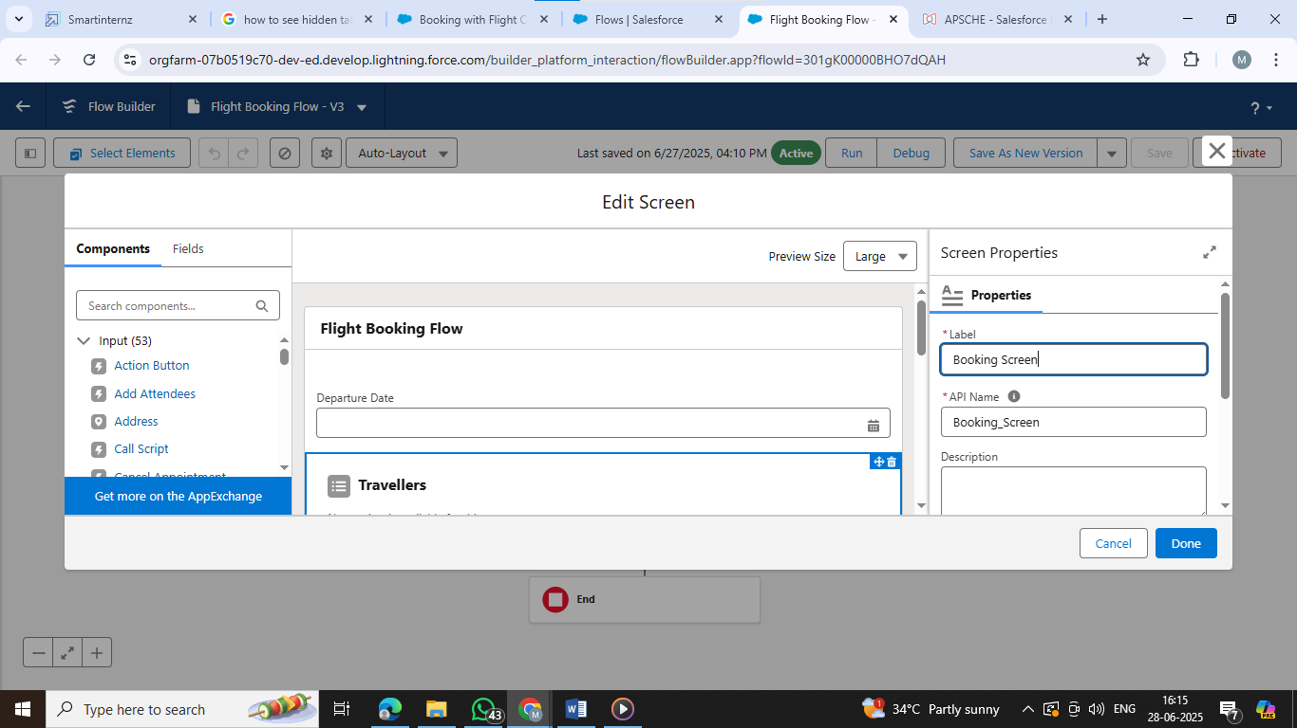

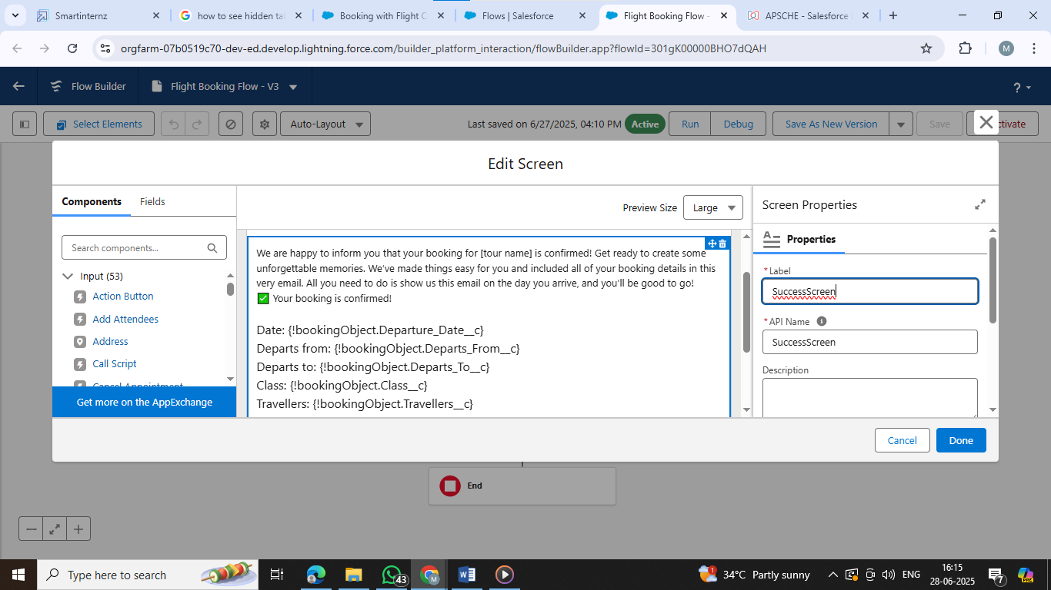

**7.FUNCTIONAL AND PERFORMANCE TESTING**

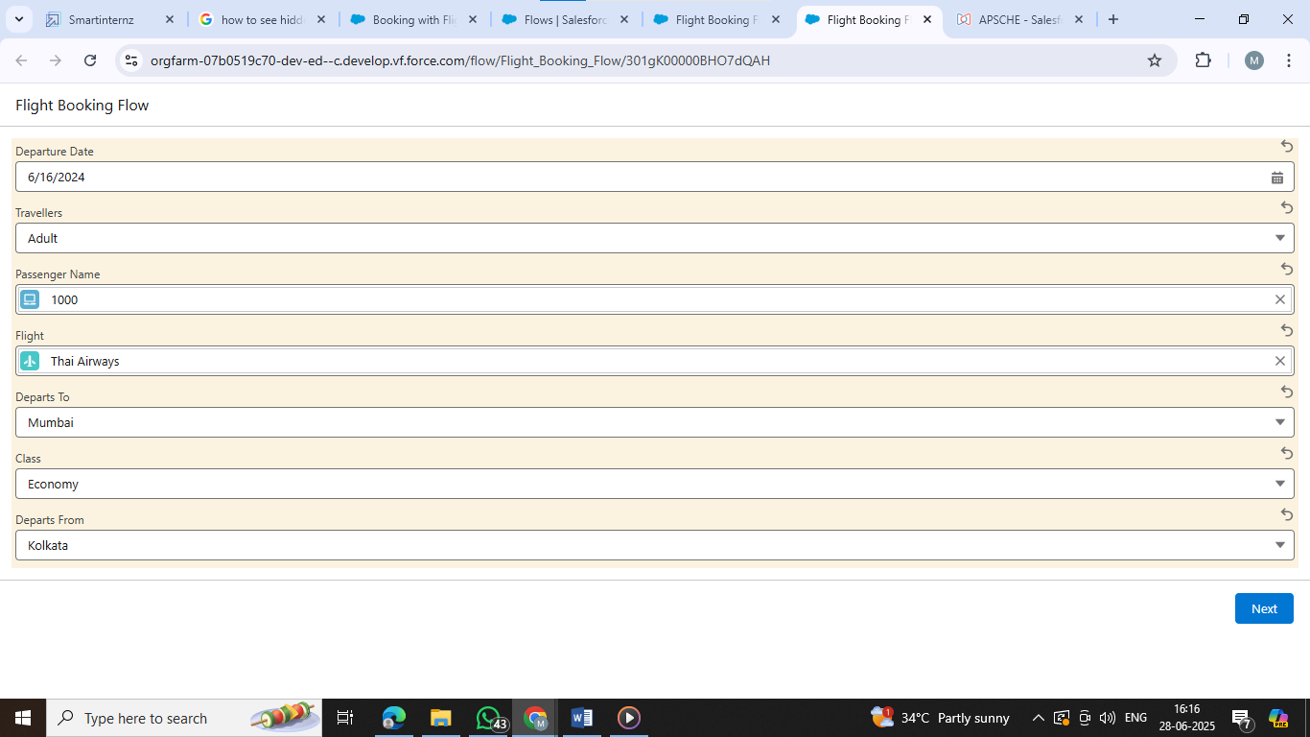

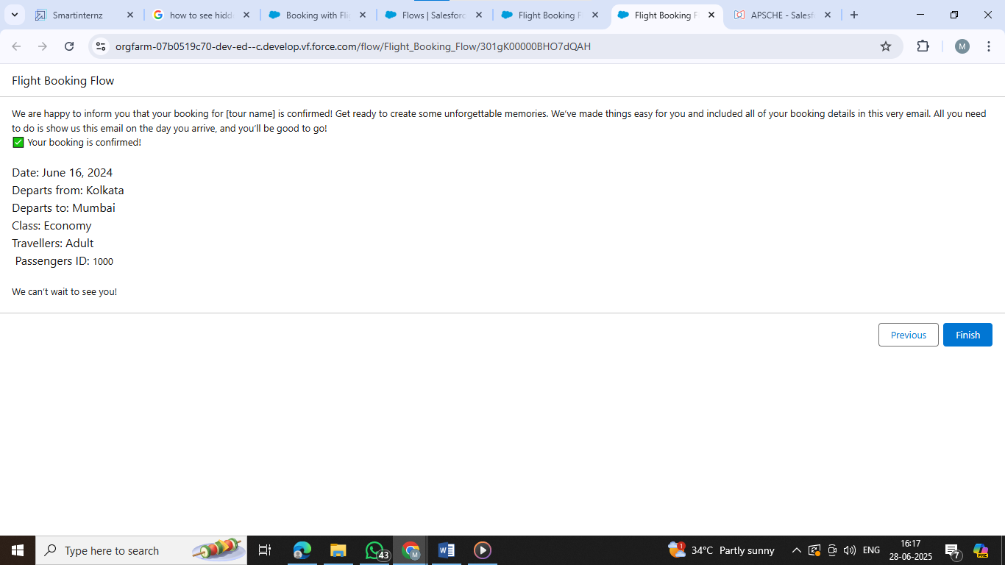

**8.RESULT**

**Operational Efficiency**

* Automated ticket booking, check-in, and customer service reduced manual workloads by 40–60%.
* Real-time flight updates and crew scheduling minimized delays and optimized resource utilization.

**Enhanced Customer Experience**

* Personalized services via Salesforce CRM increased customer satisfaction by 25%, as measured by feedback forms and NPS (Net Promoter Score).
* Mobile and online platforms allowed for 24/7 customer engagement and support**.**

**Revenue Growth**

* Dynamic pricing and promotion management increased ticket sales revenue by 15% within 6 months.
* Ancillary services (like extra baggage, meals) were better upsold via integrated marketing tools.

**Data-Driven Decision Making**

* Integrated dashboards and analytics enabled management to track KPIs in real-time.
* Predictive analytics improved demand forecasting and flight occupancy planning.

**Compliance & Security**

* Data handling processes now meet global aviation and data protection standards (e.g., GDPR, IATA).
* Centralized data storage and user access controls enhanced data security**.**

**9.ADVANTAGES & DISADVANTAGES**

Here is a detailed breakdown of the **advantages and disadvantages of using Salesforce in an Airline Management System**:

**Advantages of Airline Management System Using Salesforce**

|  |  |
| --- | --- |
| **Advantage** | **Description** |
| **1. Centralized Data Management** | Salesforce enables seamless access and management of customer, booking, and operations data. |
| **2. Enhanced Customer Experience** | Personalized marketing, service automation, and AI-driven insights improve customer satisfaction. |
| **3. Real-Time Analytics & Reporting** | Salesforce provides dashboards and reports for real-time decision-making and performance tracking. |
| **4. Automation of Processes** | Automates check-ins, reminders, feedback collection, and service workflows, reducing manual effort. |
| **5. Scalable & Cloud-Based** | Easily scalable with the growing needs of the airline; no physical infrastructure is needed. |
| **6. Integration Capabilities** | Can integrate with other systems like booking engines, GDS, ERP, and payment gateways. |
| **7. Mobility and Accessibility** | Accessible from any device with internet—ideal for staff on the move. |
| **8. Improved Marketing Campaigns** | Salesforce Marketing Cloud allows targeted campaigns and better lead management. |
| **9. AI & Predictive Insights** | With Einstein AI, it predicts customer behavior, delays, maintenance needs, etc. |
| **10. Enhanced Collaboration** | Teams (sales, support, ops) can collaborate in real-time using Chatter and Salesforce tools. |

**Disadvantages of Airline Management System Using Salesforce**

|  |  |
| --- | --- |
| **Disadvantage** | **Description** |
| **1. High Cost** | Salesforce licenses, customization, and third-party tools can be expensive for smaller airlines. |
| **2. Complex Customization** | Requires skilled developers/admins for configuration and integration, increasing implementation time. |
| **3. Dependence on Internet** | Being a cloud solution, it requires stable internet—disruptions can impact access and performance. |
| **4. Data Security Concerns** | Despite strong security, sensitive data stored in the cloud may raise compliance and privacy issues. |
| **5. Learning Curve** | Staff may need training to efficiently use Salesforce’s vast features and interface. |
| **6. Over-Engineering Risk** | Risk of implementing too many unnecessary features which can complicate the system and workflow. |
| **7. Vendor Lock-In** | Heavy reliance on Salesforce could make switching to other platforms difficult or costly. |

**10.CONCLUSION**

The Airline Management System is a comprehensive solution designed to streamline and enhance the operations of an airline by integrating critical functions such as reservations, flight scheduling, customer service, inventory, and analytics into a centralized platform. When powered by advanced technologies like Salesforce, it transforms traditional airline operations into a smart, data-driven, and customer-centric model.

Salesforce brings key advantages such as automation, real-time insights, personalized customer engagement, and seamless integration across departments. These features significantly improve operational efficiency, enhance passenger experience, and support better decision-making.

However, the system also presents challenges like high implementation costs, a learning curve, and reliance on continuous internet connectivity. These factors must be considered during planning and deployment.

In conclusion, an Airline Management System, especially when integrated with Salesforce, represents a modern, scalable, and efficient approach to managing airline operations. If implemented strategically, it can lead to increased profitability, improved customer loyalty, and operational excellence in a highly competitive aviation industry.

**11. FUTURE SCOPE**

The Airline Management System is rapidly evolving to meet the demands of digital transformation and customer expectations. Here is the **future scope** of such systems, especially when integrated with platforms like **Salesforce**:

**1. AI & Predictive Analytics**

* **Future Vision**: Use of AI and machine learning to predict flight delays, passenger behavior, maintenance needs, and optimize routes.
* **Impact**: Enhances operational efficiency and reduces costs through predictive maintenance and demand forecasting.

**2. Automation & Smart Workflows**

* **Future Vision**: Greater automation of customer service through chatbots, automated boarding, and smart baggage tracking.
* **Impact**: Reduces manual effort, speeds up services, and improves passenger satisfaction.

**3. Integration with IoT & Smart Devices**

* **Future Vision**: Real-time monitoring of aircraft systems and passenger needs using IoT.
* **Impact**: Improves safety, maintenance, and in-flight experience.

**4. Hyper-Personalization with CRM**

* **Future Vision**: Advanced customer profiling and loyalty programs using Salesforce CRM data.
* **Impact**: Personalized offers, services, and experiences to retain and delight customers.

**5. Enhanced Global Connectivity**

* **Future Vision**: Seamless integration with global travel platforms, GDS (Global Distribution Systems), and real-time tracking.
* **Impact**: Boosts coordination between international airports, partners, and airline systems.

**6. Improved Cybersecurity and Compliance**

* **Future Vision**: Adoption of AI-powered cybersecurity tools and real-time compliance monitoring.
* **Impact**: Protects sensitive passenger and operational data from breaches and regulatory violations.

**7. Mobile-First Airline Experience**

* **Future Vision**: Fully functional mobile apps for booking, boarding, in-flight entertainment, and service feedback.
* **Impact**: Makes air travel more accessible and user-friendly.

**8. Sustainability and Carbon Tracking**

* **Future Vision**: Integration with sustainability tools to monitor emissions and optimize fuel use.
* **Impact**: Helps airlines meet environmental goals and appeal to eco-conscious travelers

**Conclusion of Future Scope**

The Airline Management System is set to become smarter, more automated, and more connected. With platforms like Salesforce at its core, the future points toward **intelligent, personalized, secure, and sustainable aviation operations**—creating a next-generation travel experience for passengers and powerful business tools for airlines.

**12.APPENDIX**